Lab Experiment: Basic Image Handling and Processing Operations
Experiment No: 2
Aim
To read an image using Python and apply Gaussian Blur to smooth the image using the OpenCV library.

Tools Required
- Python 3.x
- OpenCV (cv2)
- NumPy
- VS Code / PyCharm / Jupyter Notebook
- Input Image

Procedure
- Install the OpenCV library using:
pip install opencv-python
- Import the OpenCV library.
- Read the input image using cv2.imread().
- Display the original image.
- Apply Gaussian Blur using cv2.GaussianBlur().
- Display the blurred image.
- Wait for a key press and close all image windows.

Code
import cv2

# Step 1: Read the image
img = cv2.imread("sample.jpeg")

# Check if image is loaded
if img is None:
print("Error: Image not found")
else:
# Step 2: Apply Gaussian Blur
blur = cv2.GaussianBlur(img, (5, 5), 0)

# Step 3: Save the blurred image
cv2.imwrite("blur_image.jpg", blur)

# Step 4: Display images
cv2.imshow("Original Image", img)
cv2.imshow("Gaussian Blur Image", blur)

cv2.waitKey(0)
cv2.destroyAllWindows()
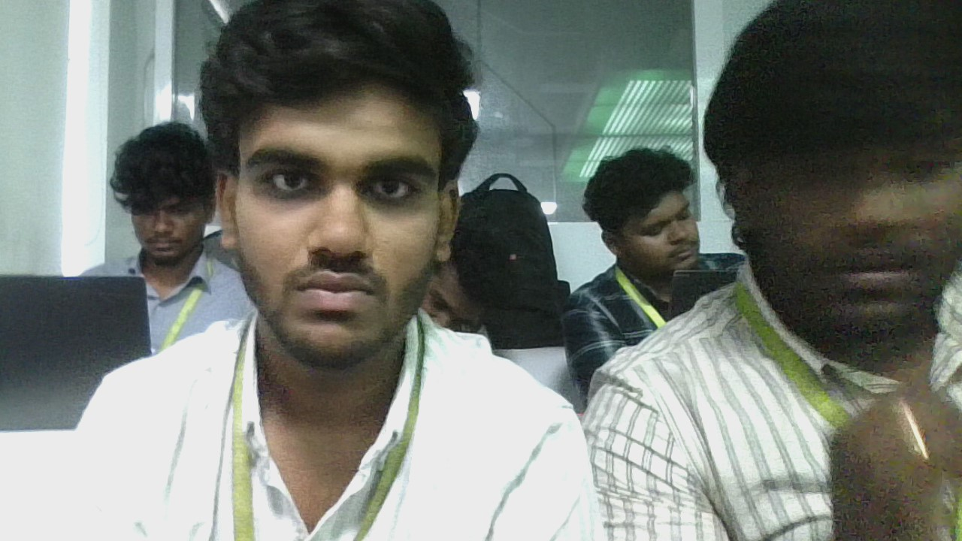
Output


Result
The input image was successfully read using Python, and Gaussian Blur was applied using the OpenCV library. The blurred image was displayed successfully.

